Design Patterns Research
Under the Esteemed Guidance of
Prof Dinesha. K. V.

IIITBangalore
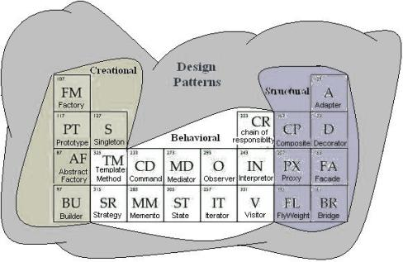
By,
Venkata Thippanna Rao. P. R. 2005145
Shahid Kamal 2005115
Supported By,
Rajendra Reddy. N. (Infosys)
Ravi Kumar. T. N. (i2 Technologies)

CONTENTS

- Preface:
- Acknowledgement:
  - My Supporters
  - My Team
- Introduction:
  - Why Design Patterns?
  - What are OOPs Principles?
  - Are these OOPs Principles sufficient?
  - Why is Polymorphism that important and how is that related to Composition?
  - Exploring the differences between Abstract Classes and Interfaces both meant by the term “INTERFACE” in Patterns language!
  - Classics and Classification?
  - Format and Vocabulary Followed!
- Patterns Classified for Ease of Understanding: As per GOF Standard
    - Creational Patterns FABPS
      - Factory Pattern
      - Abstract Factory Pattern
      - Builder Pattern
      - Prototype Pattern
      - Singleton Pattern
    - Structural Patterns ABCDFFP
      - Adapter Pattern
      - Bridge Pattern
      - Composite Pattern
      - Decorator Pattern
      - Façade Pattern
      - Fly Weight Pattern
      - Proxy Pattern
    - Behavioral Patterns CCIIMMTOSSV
      - Chain of Responsibility Pattern
      - Command Pattern
      - Iterator Pattern
      - Interpreter Pattern
      - Mediator Pattern
      - Memento Pattern
      - Template Pattern
      - Observer Pattern
      - Strategy Pattern
      - State Pattern
      - Visitor Pattern
- Issues related to Patterns: Worth a Discussion and Debatable Topics…
- Research Topic:
Problem Statement
Milestones
- Study details of and/or abstract of
“Integration Ready Architecture and Design”
By Jeff Zhuk
- References

CREATIONAL PATTERNS:
The creational patterns deals with the creation/instantiation of objects in the best possible way
F for Factory
A for Abstract Factory
B for Builder
P for Prototype
S for Singleton
……………. Many more to be discovered…. “FABPS” in all

F for FACTORY PATTERN of FABPS

Two kinds of factory patterns
  - Simple Factory Method pattern
  - Factory Pattern

1. Simple Factory Method Pattern diagram

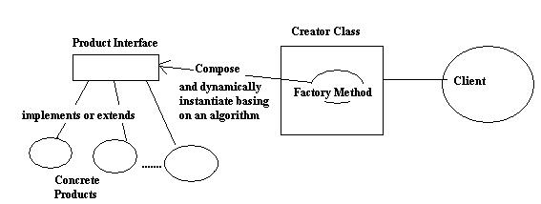

- Pattern Name: Simple Factory Method Pattern

- Reference: “Head First Design Patterns”

- Definition: This is not a full fledged design pattern, but it is a way to solve the problem of instantiation in a very simple way. The problem of decoupling can be solved in creating a product whose type among a range of products can only be known at run time.

- Description: This pattern is effective in incorporating the principle i.e.., the class should be closed for modification but open for extension. How ever, the application of this pattern is not worth if the chances of extension of the product manufacturing plant to different places to satisfy different types of customers in analogy sense.

- Design Principles: Classes should be open for extension but they should be closed for modification.

- Application Areas:

- Ideas Provoked: Though this pattern is mentioned as a simple technique in incorporating the design principle of closed for modification but open for extension, this pattern is helpful to be implemented in cases where the requirements confirm that the further change of franchising do not occur. As incorporating the below explained factory pattern in that scenario is quite messy and not needed.

2. Factory Pattern

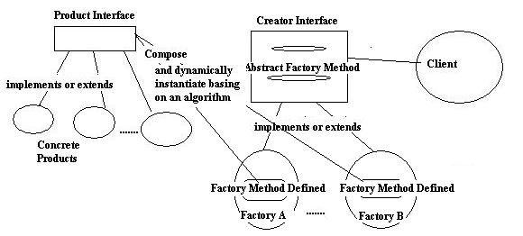

- Pattern Name: Factory Pattern

- Reference: “Head First Design Patterns”

- Definition: It defines an interface for creating an object, but let subclasses decide which class to instantiate. Factory pattern lets a class defer instantiation to the subclasses.

- Description: This Pattern can be used in the situations where there is some product sort of things are to be made and whose type among a group of products is known only at the runtime. As this pattern strictly follow the Dependency Inversion Principle the decoupling is clearly done as both the high level classes and the low level classes are dependent on the abstraction but not the other way around in which the high level classes are dependent on the concrete low level classes.

- UML Notation/ Diagram:

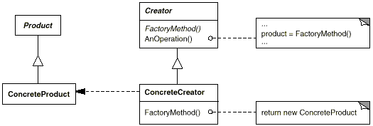

- Design Principles:
Depend on Abstraction. Do not depend on concrete classes.

- Application Areas:

- Ideas Provoked: This pattern is better than the previous simple factory pattern in that here the franchises or the sub divisions can be effectively brought back into the scenario.

- Related Patterns :
- Abstract Factory is often implemented with factory methods.
- Factory methods are usually called within Template Methods.
- Prototypes don't require subclassing Creator. However, they often require an Initialize operation on the Product class. Creator uses Initialize to initialize the object. Factory Method doesn't require such an operation.

A For Abstract Factory Pattern of FABPS

In simple terms Abstract factory is a factory object that returns one of several Factories.

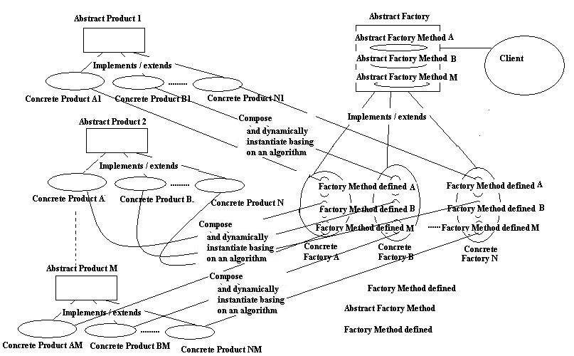

- Pattern Name: Abstract Factory Pattern

- Reference: “Head First Design Patterns”

- Definition: It provides an interface for creating families of related or dependent objects without specifying their concrete classes.

- Description: This pattern further decouples the product making method ex: prepare method by making it abstract and allowing the product to be made according to the specified area or the region. And this pattern also decouples the classes as is done by the factory pattern.

- UML Notation/ Diagram:

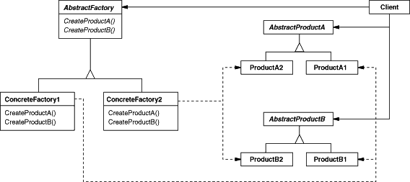

- Design Principles:
Depend on Abstraction. Do not depend on concrete classes.

- Application Areas:

- Ideas Provoked: As this pattern is just an extension of the customary Factory pattern, this pattern can be employed in cases where there are chances of having different sort of raw materials involved in the product prepare process and these raw materials vary from region to region.

- Related Patterns :
- Abstract Factory classes are often implemented with factory methods Factory Method, but they can also be implemented using Prototype.
- A concrete factory is often a Singleton (Singleton).

B for Builder Pattern of FABPS

- Pattern Name: Builder Pattern

- Reference: “Head First Design Patterns”

- Definition: Builder pattern encapsulates the construction of a product and allow it to be constructed in steps.

- Description : Builder Pattern is more or less like Abstract Factory Pattern.
There are two differences between the two basically
- Builder pattern focuses on constructing a complex object step by step where as Abstract Factory emphasis on family of product objects.
- Builder returns the product as the final step but, Abstract factory returns the product immediately.
These two basically differs with the intent the Builder by the name delivers the product after following a sequence of steps in its preparation and returns at last. But, abstract factory on the other hand returns the product from classes of products.
- Diagram:

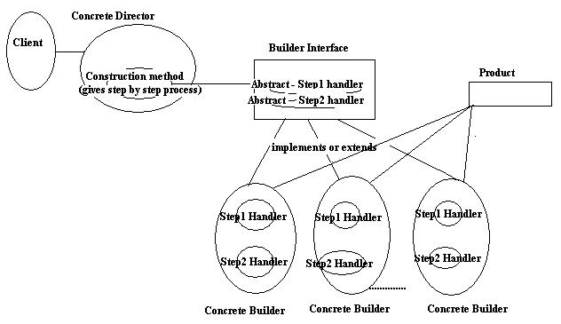

- UML Diagram
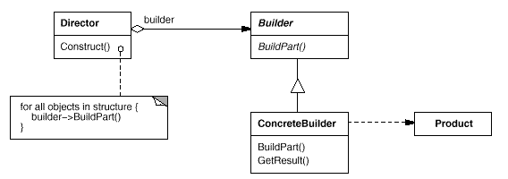

- Related Patterns :
- Abstract Factory is similar to Builder in that it too may construct complex objects. The primary difference is that the Builder pattern focuses on constructing a complex object step by step. Abstract Factory's emphasis is on families of product objects (either simple or complex). Builder returns the product as a final step, but as far as the Abstract Factory pattern is concerned, the product gets returned immediately.
- A Composite is what the builder often builds.

P For Prototype Pattern of FABPS

- Pattern Name: Prototype Pattern

- Reference: “Head First Design Patterns”

- Definition: Prototype Pattern is used to create instances of a given class which is either expensive or complicated to create.

- Description: This pattern is employed in cases when the creation or instantiation of class is expensive in either memory parameter or time consuming parameter or both. Instead of creating more instances just create the copies (or clone) of the instance.

- Diagrammatic Representation:

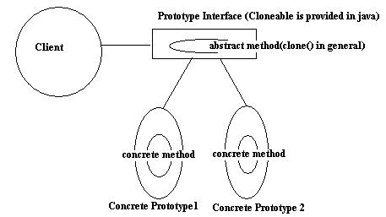
- UML Diagram
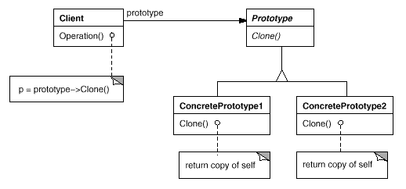
- Related Patterns :
- Prototype and Abstract Factory are competing patterns in some ways, as we discuss at the end of this chapter. They can also be used together, however. An Abstract Factory might store a set of prototypes from which to clone and return product objects.
- Designs that make heavy use of the Composite and Decorator patterns often can benefit from Prototype as well.

S for Singleton of FABPS

- Pattern Name: Singleton

- Reference: “Head First Design Patterns”

- Definition: To ensure a class has only one instant and to have a global point of access to it.

- Description: The Singleton can be in many ways. Like Eager Instantiation and Lazy instantiation. The debatable topics like whether Singleton is fit for extending or not. And the topics of Multi Threading are explained below.

- Diagram:

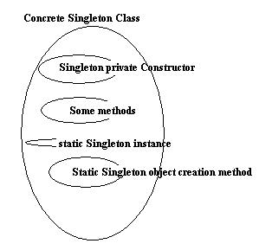

- Design Principles:

- UML Diagram :
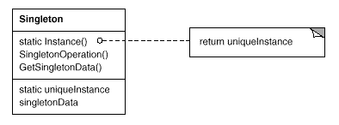

- Application Areas:

- Ideas Provoked:

The Singleton class has the following legacies

1. Can't be extended if you use a private constructor and if protected constructor is the case it can be extended but, Singleton pattern generally not intended to be extended. If at all the context demands use a protected constructor to extend it.
2. If used to extend a private constructor the Class loader fails.
- Related Patterns :

- Abstract Factory
- Builder
- Prototype

- Discussion on Singleton and Multi Threading Consequences:
Ravi of i2 Technologies Says… dated 20/7/2006
Hi, I have a doubt regarding Singleton Pattern... It is as follows..."Singleton pattern would be a problem if one thread ( or user) wants to change a member and another thread (or user) does not"... My question - Is singleton pattern used only where the threads are allowed to read the members but not modify them? If this is not the case and if the above scenario occurs what is going to be the solution to this problem?
NOTE: By member I mean data member(s) of the singleton object....To my knowledge, in VC++, the so called "application object" is a singleton and we use global access points (functions) to get some info but not to set some info.... check this out.... If this is true then My Question is true.....
What is Ur feedback?

Pandurang Says… Project Leader of Delphi Softwares
Sorry Ravi...I was busy and could not answer Ur question. Well, Singleton is nothing but having a static instance of a class and the first thread (request) is allowed to create the instance once and for all other subsequent requests, same instance is being used...So, at any given time, there will be only one instance of that class in memory...Now as you said, if 2 different threads (requests) access the same attribute of the instance, there are many different possible scenarios:
1: If both the threads tries to read the same attribute, NO ISSUES
2: If one tries to modify and other to tries to read, second thread might read inconsistent state of the instance [before the first thread finish modifying the state of the instance completely] – UNREPEATABLE READS/DIRTY READS
3: If both the threads try to modify the state of the instance –second instance might overwrite some of the attributes of the instance while the first instance is still in the process of modifying the state of the instance.
As a programmer, u should make all the static and instance methods synchronized, so that there will an object/class lock coming into picture when more than one thread/requests tries to access the same instance

Now, one question to u...When do u think, Singleton pattern is preferred

Bye
Pandurang

Ravi says…

Hi,
Consider this scenario...
Each and every device attached to a PC has a so called driver which is nothing but an interface between the program and the hardware device.
Now suppose you have a printer attached to your PC and obviously there are many threads in the system trying to gain access to the printer; assuming that each and every thread/program in execution in the system has its own copy of the printer driver (remember that there is only one printer) will go ahead and start printing as required, can u imagine the result? Yes correctly u will get a mixed output firstly, secondly driver will have attributes to set the resolution of the printer etc, now assuming each and every thread has its own instance of the printer driver would definitely have different values set to the attributes which again is a chaos, thirdly deadlock is possible candidate in these kind of situations.
To avoid above situation, it is better to have only one instance of 'printer driver' in the memory and proper management of this printer driver's monitor between threads is needed by enforcing appropriate synchronization primitives (like 'synchronized' in java). Here 'Singleton Pattern' seems to be a candidate.
Coming to your previous reply,

I totally agree with u, b'coz the programmer has to be intelligent enough to tackle these problems, and java provides the programmer 'synchronized' keyword for this.
My only doubt from Ur reply is you said 'static instance of a class', does this mean a globally unique instance or does this have something to do with java 'static'?

Pandu Says…

To answer Ur question regarding static, in java, we implement the singleton pattern by having a static instance variable which gets loaded as soon as class gets loaded in JVM and having a private default constructor.
This variable is later made to refer to an instance when the first request arrives.
For example:
public class STPattern {
static private STPattern pattern = null;
public static STPattern getInstance() {
if ( pattern == null ) {
pattern = new STPattern ();
}
return pattern;
}
//private Constructor
private STPattern(){
}
}

(Venkat) I Say…

The word static universally in programming context refers to something that is common to everything in the software system...

I agree with U people saying that Programmer should be smart enough in using singleton pattern in a multi threaded program where the class have both setters along with getters... but here Synchronized keyword alone wont help because what do that feature synchronized do it just schedules the thread to handle the critical section in an efficient way, but it doesn’t consider the effects of value change....

Consider this example that U got a dynamic object composition feature embedded into ur singleton class...
By default in constructor the object is set to Y....then there is a setter method to set the object handled by the singleton object dynamically by the client...
Then if client A comes and resets it to something else say X in first step.....
Client B is waiting for that and unknowingly it got to use the object 'X' composed by Client A.....instead of Y it expects by default....
Here, no Synchronized keyword works only the programmer smartness works..........

Singleton pattern is particularly applicable in contexts as listed below as far I think
1. When the resource the class is mediating is of big size, like the graphical resources then better to make the class singleton.

2. In case of Critical resources, I mean the resources which require mutual exclusion principle to be followed in that case we can go for a singleton pattern and have custom singleton exception defined, so that when ever a request is made to access the resource through singleton object which already used by thread A say,, exception is thrown and handled to schedule the requesting thread to wait accordingly.....

For details how to write a custom singleton exception refer "The Design patterns java Companion" by James W. Cooper Addison-Wesley Design Patterns series.

3. In the context where if U are of sure that the class have only getters and no setters then it is safe to go for a making the class a singleton... I am rephrasing the words what Mr. Pandu Rangan said.

4. And many more contexts left to be discovered!

Ravi says…

Yeah Venky,

I totally agree with u about 'the' dynamic object composition funda; yeah I give it to you... The programmer has to be smart enough here.

The scenario u presented is as follows -

Consider this example that U got a dynamic object composition feature embedded into Ur singleton class...
By default in constructor the object is set to Y....
Then there is a setter method to set the object handled by the singleton object dynamically by the client...
Then if client A comes and resets it to something else say X in first step.....
Client B is waiting for that and unknowingly it got to use the object 'X' composed by Client A.....instead of Y it expects by default....

Yeah the programmer has to be smart here and make some 'VALIDATIONS' in the code so that if Client B finds 'X' in the place of 'Y', it does some 'chore' validation activity and then proceeds further; u can say this is all req. specific or design specific or what ever term fits.....

Finally at the end of the day, you gotta use Singleton if u gotta go for it (after taking into consideration all such above mentioned aspects...)

"MAGIC OF DESIGN DECISION"

STRUCTURAL PATTERNS:
The Structural Patterns are concerned with how classes and objects are composed to form larger structures.
A for Adapter
B for Bridge
C for Command
D for Decorator
F for Façade
F for Fly Weight
P for Proxy
……………. Many more to be discovered…. “ABCDFFP” in all

A For Adapter (of ABCDFFP)

- Pattern Name: Adapter Pattern (wrapper pattern)

- Reference: “Head First Design Patterns”

- Definition: The Adaptor Pattern converts the interface of the class into another interface the clients expect. Adaptor lets the classes work together that couldn’t otherwise because of incompatible interfaces.

- Description:

- The Adapter Pattern lets classes with incompatible interfaces work together. This is sometimes called a wrapper because an adapter class wraps the implementation of another class in the desired interface. This pattern makes heavy use of delegation where the delegator is the adapter (or wrapper) and the delegate is the class being adapted

- The basic idea is to convert the interface of some class “b” into an interface “a” that some client class “c” understands.
There are basically two types of adapter patterns:
- The Object Adapter pattern - In this type of adapter pattern the adapter contains an instance of the class it wraps. In this situation the adapter makes calls to a physical instance of the wrapped object.

- The Class Adapter pattern - This type of adapter uses multiple inheritance to achieve its goal. The adapter is created inheriting interfaces from both the interface that is expected and the interface that is pre-existing. The Object Adapter pattern is more often used as some popular languages, such as Java, do not support true multiple inheritance as the designers of these languages consider it a dangerous practice.

- Diagram:
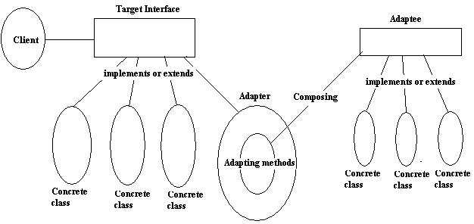

- Design Principles:
A class adapter
- lets Adapter override some of Adaptee's behavior, since Adapter is a subclass of Adaptee.
- adapts Adaptee to Target by committing to a concrete Adapter class. As a consequence, a class adapter won't work when we want to adapt a class and all its subclasses.
- introduces only one object, and no additional pointer indirection is needed to get to the adaptee.
An object adapter
- lets a single Adapter work with many Adaptees—that is, the Adaptee itself and all of its subclasses (if any). The Adapter can also add functionality to all Adaptees at once.
- makes it harder to override Adaptee behavior. It will require subclassing Adaptee and making Adapter refer to the subclass rather than the Adaptee itself.

- Application Areas:
- Pluggable adapters are common in ObjectWorks\Smalltalk
We generally use the Adapter pattern when :
- we want to use an existing class, and its interface is not compatible with another existing class.
- we want to create a reusable class that cooperates with unrelated or unforeseen classes, that is, classes that don't necessarily have compatible interfaces.
- (for object adapter only) you need to use several existing subclasses, but it's impractical to adapt their interface by subclassing every one. An object adapter can adapt the interface of its parent class.
- UML Diagram

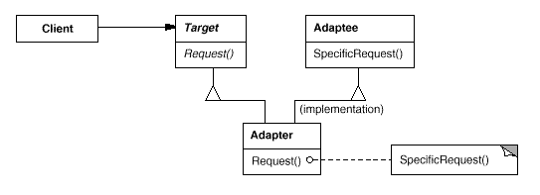
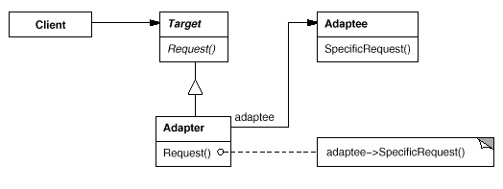

- Ideas Provoked:
- The adapter pattern is useful in situations where an already existing class provides some or all of the services you need but does not use the interface you need.
- The amount of work Adapter does depends on how similar the Target interface is to Adaptee's.
- A class is more reusable when one minimizes the assumptions other classes must make to use it.

- Related Patterns :

- Bridge : It has a structure similar to an object adapter, but Bridge has a different intent:

- Decorator : It enhances another object without changing its interface. A decorator is thus more transparent to the application than an adapter is. As a consequence, Decorator supports recursive composition, which isn't possible with pure adapters.

- Proxy : Proxy defines a representative or surrogate for another object and does not change its interface.

B For Bridge Pattern(of ABCDFFP)

- Pattern Name: Bridge (Handle/Body)

- Reference: “Head First Design Patterns”

- Definition: Bridge Pattern can be employed to vary not only implementations but also abstractions.

- Description: Consider that the interface/abstraction have some x, y and z methods. Then all the concrete implementers got to define those methods. If a new method P comes which is just an extension of the available methods we got to declare it in interface and there by our implementers got to provide the implementation for the same. Here the smartness that can be embodied is to handle the method P using method that can be extended. Here it is not possible as the concrete implementers can be some devices like TV’s and the interface is the remote. To over come we are with the solution of separating the interface from its implementation.

As shown in the diagram below we can have x ,y ,z methods to be adapted over to implementer by means of composing the implementer in Abstraction or Interface. There by any new extendable functionality comes it can be defined in the Abstraction and make use of implementer which is composed to make use of the available functionality. So it is a special case of Adapter.
We call this Smart Adapter.

- Diagram:
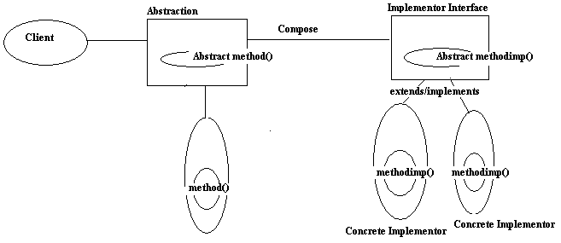

- Design Principles:

- UML Diagram :

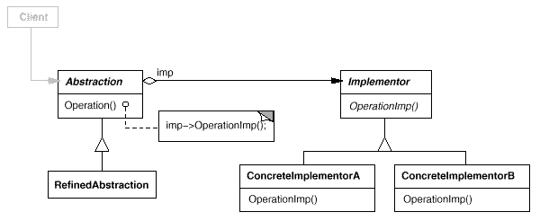

- Application Areas:

- Ideas Provoked:

- Related Patterns :

- An Abstract Factory can create and configure a particular Bridge.
- The Adapter pattern is geared toward making unrelated classes work together. It is usually applied to systems after they're designed. Bridge, on the other hand, is used up-front in a design to let abstractions and implementations vary independently.

C For Composite Pattern (of ABCDFFP)

- Pattern Name: Composite

- Reference: “Head First Design Patterns”

- Definition: Composite pattern can be employed to compose objects into tree structures to represent part –whole hierarchies . Composite lets client treat individual objects and compositions of objects uniformly.

- Description:

- UML Notation/ Diagram:
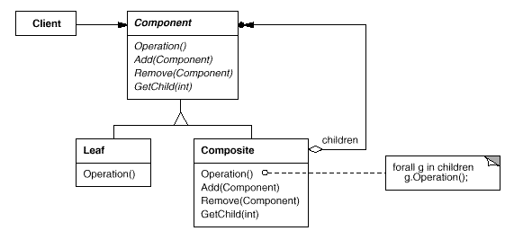

- Design Principles:

- Application Areas:

- Ideas Provoked:

- Related Patterns :

- Often the component-parent link is used for a Chain of Responsibility .
- Decorator is often used with Composite. When decorators and composites are used together, they will usually have a common parent class. So decorators will have to support the Component interface
- Flyweight lets you share components, but they can no longer refer to their parents.
- Iterator can be used to traverse composites.
- Visitor localizes operations and behavior that would otherwise be distributed across Composite and Leaf classes.

D For Decorator Pattern (of ABCDFFP)

- Pattern Name: Decorator

- Reference: “Head First Design Patterns”

- Definition: Decorator pattern attaches additional responsibilities dynamically .Decorators provides a flexible alternative to sub classing for extending functionality.

- UML Notation/ Diagram:

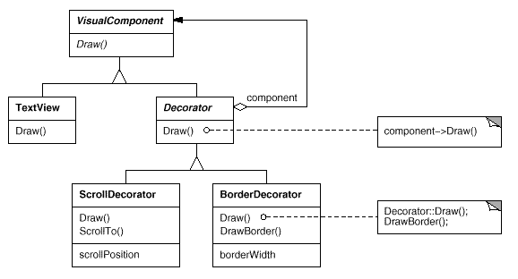

- Design Principles:

- Application Areas:

- Ideas Provoked:
- Related Patterns :
- Adapter : A decorator is different from an adapter in that a decorator only changes an object's responsibilities, not its interface; an adapter will give an object a completely new interface.
- Composite : A decorator can be viewed as a degenerate composite with only one component. However, a decorator adds additional responsibilities—it isn't intended for object aggregation.
- Strategy : A decorator lets you change the skin of an object; a strategy lets you change the guts. These are two alternative ways of changing an object.

F For Facade Pattern (of ABCDFFP)

- Pattern Name: Facade Pattern

- Reference: “Head First Design Patterns”

- Definition: The Façade Pattern provides a unified interface to s set of interfaces in a sub system. Facade defines a higher level interface that makes the subsystem easier to use.

- Description:

- The Facade pattern allows us to avoid tight coupling between clients and the subsystem easier to use.

- Implementing a façade requires that we compose the façade with its subsystem and use delegation to perform the work of the façade.

- Wrap a complicated subsystem with a simpler interface

- UML Notation/ Diagram:
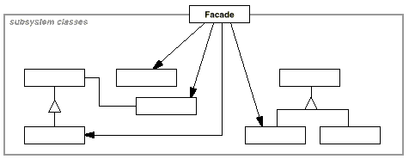

- Design Principles:
- While designing a system, keep a check of the number of classes an object interacts with and also how it interacts with those classes.

- Application Areas:

- An application in an application frame work can have built in browsing tool for inspecting objects at the run time. These browsing tools are implemented in a separate subsystem that includes a Facade class called “Programming Environment."

- The Choices operating system uses facades to compose many frameworks into one.

Basically the façade pattern is used when there is a complex subsystem asnd we want to provide a simple interface to it or when there are many dependencies between clients and the implementation classes of abstraction.If subsystems are dependent, then façades can be used to make them communicate with each other.

- Ideas Provoked:

- It’s better to create designs that have less number of classes coupled together, so that changes in one part of the system cascade to the other parts.
- More than one façade can be implemented for a subsystem.
- The Facade defines a unified, higher level interface to a subsystem that makes it easier to use.
- The number of objects that the client directly interacts with is reduced by using façade pattern , thus its easier to use the system.
- It promotes weak coupling between the subsystem and its clients.

- Related patterns :
- Abstract factory : It can be used with Facade to provide an interface for creating subsystem objects in a subsystem-independent way. Abstract Factory can also be used as an alternative to Facade to hide platform-specific classes.

- Mediator : It is similar to Facade in that it abstracts functionality of existing classes. However, Mediator's purpose is to abstract arbitrary communication between colleague objects, often centralizing functionality that doesn't belong in any one of them.

F For Flyweight Pattern (of ABCDFFP)

- Pattern Name: Flyweight

- Reference: “Head First Design Patterns”

- Definition: Flyweight pattern can be employed when one instance of the class can be used to provide many virtual instances.

- Description: Reduces the number of objects at runtime thereby saving memory.

- UML Notation/ Diagram:
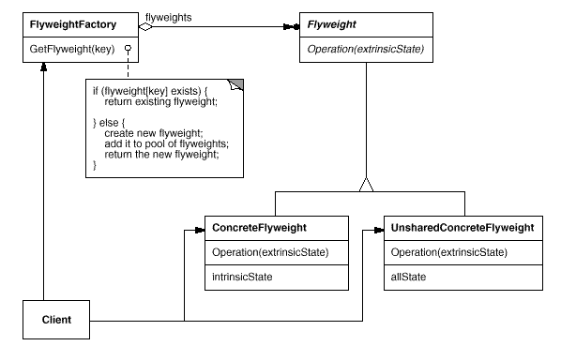

- Design Principles:

- Application Areas:

- Ideas Provoked:

- Related Patterns :
- The Flyweight pattern is often combined with the Composite pattern to implement a logically hierarchical structure in terms of a directed-acyclic graph with shared leaf nodes.
- It's often best to implement State and Strategy objects as flyweights.

P For Proxy Pattern (of ABCDFFP)

- Pattern Name: Proxy

- Reference: “Head First Design Patterns”

- Definition: Proxy pattern provides a surrogate or a place holder for another object to control access of it .

A remote proxy provides a local representative for an object in a different address space.

A virtual proxy creates expensive objects on demand.

A protection proxy controls access to the original object. Protection proxies are useful when objects should have different access rights.

- Description: Reduces the number of objects at runtime thereby saving memory.

- UML Notation/ Diagram:

- Design Principles:

- Application Areas:

- Ideas Provoked:

- Related Patterns :

- Decorator: Although decorators can have similar implementations as proxies, decorators have a different purpose. A decorator adds one or more responsibilities to an object, whereas a proxy controls access to an object.
- Adapter : An adapter provides a different interface to the object it adapts. In contrast, a proxy provides the same interface as its subject. However, a proxy used for access protection might refuse to perform an operation that the subject will perform, so its interface may be effectively a subset of the subject's.

BEHAVIOURAL PATTERNS:
The creational patterns deals with the creation/instantiation of objects in the best possible way
C for Chain of responsibility
C for Command
I for Iterator
I for Interpreter
M for Memento
M for Mediator
T for Template
O for Observer
S for Strategy
S for State
V for Visitor
……………. Many more to be discovered…. “CCIMMTOSSV” in all

C For Chain of Responsibility Pattern (of CCIIMMTOSSV)

- Pattern Name: Chain of responsibility

- Reference: “Head First Design Patterns”

- Definition: The chain of responsibility is used when we want to give more than one object a chance to handle request.

- Description:

- UML Notation/ Diagram:
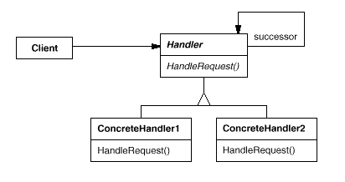

- Design Principles:

- Application Areas:

- Ideas Provoked:

- Related Patterns:
- Chain of Responsibility is often applied in conjunction with Composite .

C For Command Pattern (of CCIIMMTOSSV)

- Pattern Name: Command also known as Action , Transaction

- Reference: “Head First Design Patterns”

- Definition: The Command Pattern encapsulates a request as an object, thereby letting you parameterize other objects with different requests, queue or log requests, and support undoable operations.

- Description:
>> It can improve API design. In some cases, code that uses a command object is shorter, clearer, and more declarative than code that uses a procedure with many parameters.

>> The command is a useful abstraction for building generic components, such as a thread pool, that can handle command objects of any type. If a new type of command object is created later, it can work with these generic components automatically.

>> A command object is convenient temporary storage for procedure parameters. It can be used while assembling the parameters for a function call and allows the command to be set aside for later use.

- UML Notation/ Diagram:

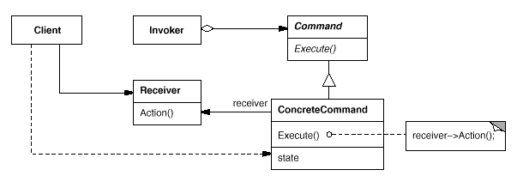
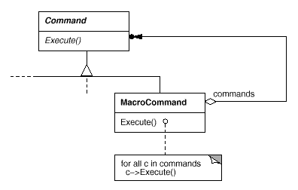
- Design Principles:
- A concrete command declares an interface for executing an operation.
- Command decouples the object that invokes the operation from the one that knows how to perform it.

- Application Areas:
• You can express such parameterization in a procedural language with a callback function, that is, a function that's registered somewhere to be called at a later point. Commands are an object-oriented replacement for callbacks.

• Specify, queue, and execute requests at different times. A Command object can have a lifetime independent of the original request.

• Support undo. The Command's Execute operation can store state for reversing its effects in the command itself.
• Support logging changes so that they can be reapplied in case of a system crash. By augmenting the Command interface with load and store operations, one can keep a persistent log of changes.

- Thought Process:

  - If all user actions in a program are implemented as command objects, the program can keep a stack of the most recently executed commands. When the user wants to undo a command, the program simply pops the most recent command object and executes its undo () method.Macro Commands can easily support undo ()

  - Undo is perhaps even more essential when it's called rollback and happens automatically when an operation fails partway through.

  - Suppose the commands are in sequence, then if each object has a method say getcommandduration() .Then the program can easily calculate the command duration. Profiling job can be done efficiently.

  - A typical, general-purpose thread pool class might have a public AddTask() method that adds a work item to an internal queue of tasks waiting to be done.

  - Invokers can be parameterized with commands, even dynamically at run time

  - Commands may also be used to implement logging and transactional system.

- Related Patterns:
- A Composite Pattern can be used for the implementation of Macro Commands.
- A Memento Pattern can keep state the command requires to undo its effect.

I For Iterator Pattern (of CCIIMMTOSSV)

- Pattern Name: Iterator

- Reference: “Head First Design Patterns”

- Definition: Iterator Pattern provides a way to access the elements of an aggregate object sequentially with out exposing its underlying representation.

- Description:

- UML Notation/ Diagram:

- Design Principles:

- Application Areas:

- Ideas Provoked:

- Related Patterns:

- Composite : Iterators are often applied to recursive structures such as Composites.
- Factory Method : Polymorphic iterators rely on factory methods to instantiate the appropriate Iterator subclass.
- Memento : is often used in conjunction with the Iterator pattern. An iterator can use a memento to capture the state of an iteration. The iterator stores the memento internally.

I For Interpreter Pattern (of CCIIMMTOSSV)

- Pattern Name: Interpreter

- Reference: “Head First Design Patterns”

- Definition: Use Interpreter Pattern to build interpreter for a language

- Description:

- UML Notation/ Diagram:
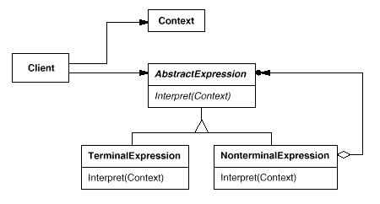

- Design Principles:

- Application Areas:

- Ideas Provoked:

- Related Pattern :
- Composite: The abstract syntax tree is an instance of the Composite pattern.
- Flyweight: shows how to share terminal symbols within the abstract syntax tree.
- Iterator : The interpreter can use an Iterator to traverse the structure.
- Visitor : can be used to maintain the behavior in each node in the abstract syntax tree in one class.

M For Memento Pattern (of CCIIMMTOSSV)

- Pattern Name: Memento

- Reference: “Head First Design Patterns”

- Definition: Use Memento Pattern when you need to be able to return object to one of its state for example if user request an undo.

- Description:

- UML Notation/ Diagram:
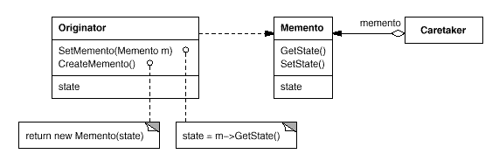

- Design Principles:

- Application Areas:

- Ideas Provoked:

- Related Patterns :

- Command : Commands can use mementos to maintain state for undoable operations.

- Iterator: Mementos can be used for iteration as described earlier.

M For Mediator Pattern (of CCIIMMTOSSV)

- Pattern Name: Mediator

- Reference: “Head First Design Patterns”

- Definition: Use Mediator to centralize complex communications and control between related objects.

- Description:

- UML Notation/ Diagram:
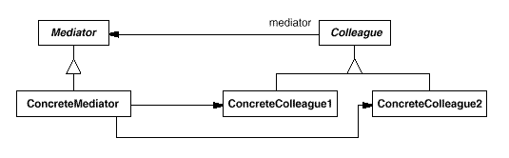

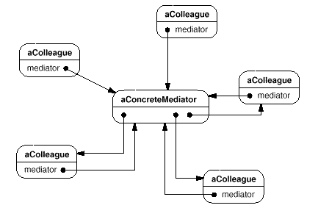
- Design Principles:

- Application Areas:

- Ideas Provoked:
- Related Patterns :
- Facade differs from Mediator in that it abstracts a subsystem of objects to provide a more convenient interface. Its protocol is unidirectional; that is, Facade objects make requests of the subsystem classes but not vice versa. In contrast, Mediator enables cooperative behavior that colleague objects don't or can't provide, and the protocol is multidirectional.
- Colleagues can communicate with the mediator using the Observer pattern.

T For Template Pattern (of CCIIMMTOSSV)

- Pattern Name: Template

- Reference: “Head First Design Patterns”

- Definition: The Template Method Pattern defines the skeleton of an algorithm in a method, deferring some steps to subclasses. Template method lets subclasses redefine certain steps of an algorithm without changing the algorithm structure.

- Description:

- UML Notation/ Diagram:
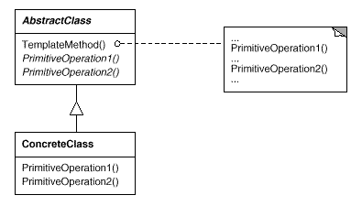

- Design Principles:

- Application Areas:

- Ideas Provoked:

O For Observer Pattern (of CCIIMMTOSSV)

- Pattern Name: Observer

- Reference: “Head First Design Patterns”

- Definition: Observer pattern defines a one to many relationships between a set of objects and when ever the state of the subject changes all its dependants or the observers are notified and updated accordingly.

- Description:
  - In this pattern there will be a Subject which holds a state or a content and a set of observers who are interested in that state change or content change.
  - The observers got to be registered with the Subject and the Subject would notify the observers when ever the state or content changes.
  - The observer can get detached themselves from being an observer by unregistering.
  - The Subject is an Interface and there will be concrete classes holding the state information which implements the Subject interface.
  - What if the Observers need different sort of Information? : The Observers should implement the Observer interface that holds the prototype of the communications between the Concrete Observers and the Concrete subject. Generally the Update() method with a standard prototype for a groups of users is defined.
  - And if other groups of users need other type of updates yet another Observer interface can be created and so on.
  - Where to have the Subject object declared? : And it can be Observed that the object of type Subject interface type can be declared either in the Observer interface or the Concrete observers, this is for registering purpose. It does not effect much how ever I feel it is preferable to be in the Interface. So that the standard is maintained. I feel so because having a declaration in the Observer interface makes a standard to be adopted by its implementers. So that the code can be easy to trace out for many implementers of the same Observer interface. But, in the Head First design patterns it is declared in the concrete observers.

- UML Notation/ Diagram:

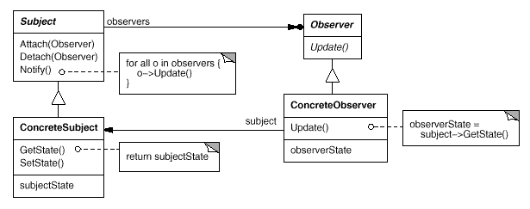

- Design Principles:
- Strive for the loosely coupled designs between objects.
- Program to interfaces not to implementation.
- Separate the things that change from the things that remain the same.
- Prefer Composition over inheritance.

- Application Areas:
Observer patterns are employed exclusively in
  - JDK
  - Java Beans
  - RMI
  - Swings

- Thought Process:
  - Here “Strive for the loosely coupled designs between objects” means that the Subject that notifies the Observers does not have any idea, what are the methods or properties of the observers or what the observers do with the updated data. It only knows the handle in the raw sense. It communicates by means of an interface here i.e.., the observer interface’s update method which is a standard prototype for all the observers as well as the Subjects.
  - The type of notifications for different types of observers can be done as explained in the description part of this pattern.
  - The ease of declaration of the Subject object that is either in the interface or the concrete implementers discussed in the description part as well.
  - Here “Separate the things that change from the things that remains the same” is employed as the state of the subject is the thing that varies in the observer pattern. And so, an interface is created to have it encapsulated.
With this one can change the observers or objects that are dependent on the state of the subject. This is called Planning Ahead.
- Here “Program to an Interface, not to an implementation” is done as the subjects and the observers are both implementing the necessary interfaces. This actually keeps the things loosely coupled.
- Here “Prefer Composition over inheritance” is done as the Observers got to compose the Subject interface object such that, it can be dynamically be allocated to the respective State and Subject.

  - Related Patterns

  - Mediator : By encapsulating complex update semantics, the Change Manager acts as mediator between subjects and observers.

  - Singleton : The Change Manager may use the Singleton pattern to make it unique and globally accessible.

S For Strategy Pattern (of CCIIMMTOSSV)

- Pattern Name: Strategy

- Reference: “Head First Design Patterns”

- Definition: Strategy Pattern defines a family of algorithms, encapsulates each of them and allows them to vary interchangeably. Strategy pattern also lets the algorithms to change accordingly from the clients that use it.
- Description:
  - Separate things that change to the things that remain constant: Strategy pattern works with the problems in which the figuring out of the things that vary to the things that remain the same is possible.
  - Meaning of Interfaces in this context: This pattern clearly uses an interface (not only java Interface, it can be an abstract class of java as well that supports dynamic object dispatch or polymorphism.. the differences between the use of java abstract classes/interfaces in place of the interface word here is explained earlier at the start of the paper).
  - Why the Word Interfaces?: The interface here is like some sort of communication between any two classes so that it enables polymorphism and there by achieve the composition concept which is the lead thing for dynamic object dispatch.
  - What is meant by separating the functionality: Here, it can be observed that the meaning of separating the functionality that remains constant is that the functionality that remains is mandatory in each of its subclasses of the main abstract parent class.
- Design Principles:
- Separate the Functionalities that remain the same from the ones that change.
- Program to Interfaces but not to implementation.
- Prefer Composition over inheritance.
- Application Areas:
- Thought Process:
  - The actual meaning of the term “Separate the things that remains the same and that varies” is figured out like, remains same means that the functionalities that are mandatory and that remain constant most of the time are to be treated as that remains same.
  - The actual meaning of the term “Interfaces” in this context is examined and why it is needed has been explained in the description part of this pattern.

- UML Notation/ Diagram:

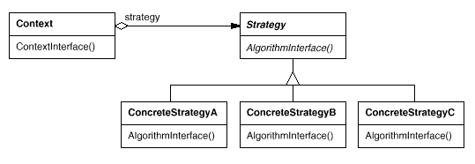

- Related patterns
- Flyweight : Strategy objects often make good flyweights.

S For State Pattern (of CCIIMMTOSSV)

- Pattern Name: State Pattern also known as the objects for states pattern

- Reference: “Head First Design Patterns”

- Definition: Allow an object to alter its behavior when it’s internal state changes. The object will appear to change its class.

- Description:
- The state pattern allows an object to have many different behaviors that are based on its internal state.
- In state patterns we encapsulate interchangeable behaviors and use delegation to decide which behavior to use.
- The State pattern puts all behavior associated with a particular state into one object. Because all state-specific code lives in a State subclass, new states and transitions can be added easily by defining new subclasses.

- UML Notation/ Diagram:

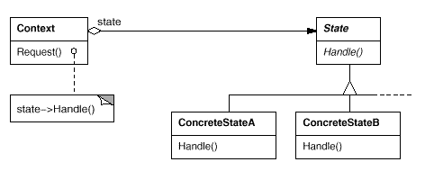

- Design Principles:

- Application Areas:
State patterns can be used when:
- When the object’s behavior depends on its state and the object may change its behavior at run time depending upon its state
- Operations have large, multipart conditional statements that depend on the object's state.

- Ideas Provoked:

- This is a clean way for an object to partially change its type at runtime. The state pattern can be used to represent a state of an object

- Introducing separate objects for different states makes the transitions more precise and clear.

- If State objects have no instance variables that is, the state they represent is encoded entirely in their type, then contexts can share a State object. When states are shared in this way, they are essentially flyweights

- Related Patterns

- Flyweight : This pattern explains when and how State objects can be shared.

- Singletons : State objects are often singleton.

V For State Pattern (of CCIIMMTOSSV)
- Pattern Name: Visitor Pattern

- Reference: “Head First Design Patterns”

- Definition: Use visitor pattern when you want to add capabilities to a composite of objects and encapsulation is not important.

- Description:

- UML Notation/ Diagram:

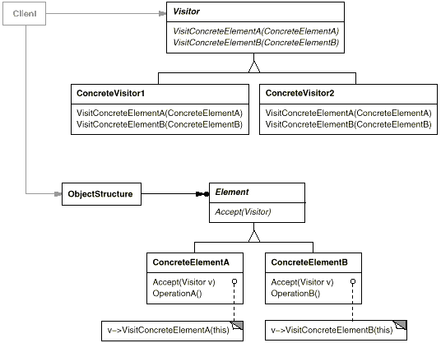

- Design Principles:

- Application Areas:

- Ideas Provoked:

- Related Patterns
- Composite: Visitors can be used to apply an operation over an object structure defined by the Composite pattern.
- Interpreter : Visitor may be applied to do the interpretation.

